**Tutorials Blog**

**Summary:**

Internal training knowledge base. - webapp

So this isnt for customers it's for staff, so will need a secure login.

Then functionality wise it's quite straight forward.

We need a list of articles and the ability to search for words in the article and article subject titles.

We also will apply tags e.g "windows 11 guide"

We will also need to be able to search for these tags in combination with the word search.

Then the other part of the project is to be able to create articles and edit, delete.

Any user can create and edit

Only admin can delete

When a user creates or edits and article admin will have a screen which shows a list of these and can click to preview, admin can edit, delete, And approve the article

When approved it shows in the normal list and search for all users.

The only things I would add is on the editor it will need full functionality e.g fonts, tables etc on other projects not in .net we have used CK editor but I am not too fussed so long as we have good editor functions.

Copy and paste pictures, text, tables from ms word etc

Some layout control would be good as well.

Tag wise, let me see if I can send you a video of how we use tags in another of our applications ...

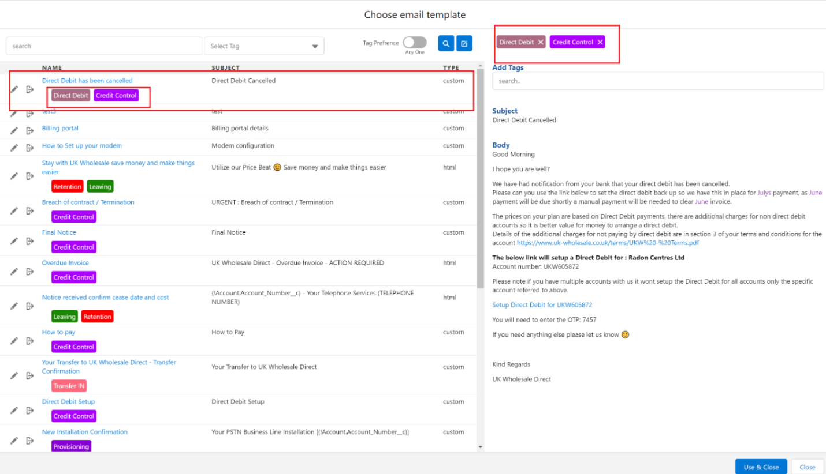

so this is similar to how I see this project looking, a list of subjects down the side and click to show it on the page on the right. Maybe with the option to shrink the left panel to make the main screen bigger once the user has found what they want to look at

Tags are assigned which enable search by tag as well as search by words

so in the search you can put fault code 223344 but in tags select window 11 so any fault 223344 for articles which dont have the windows 11 tag wont show up

also there is a toggle , to say it must have any of these tags, or it must have ALL of these tags

it is possible to enter no text and just search based on tags, or vice versa

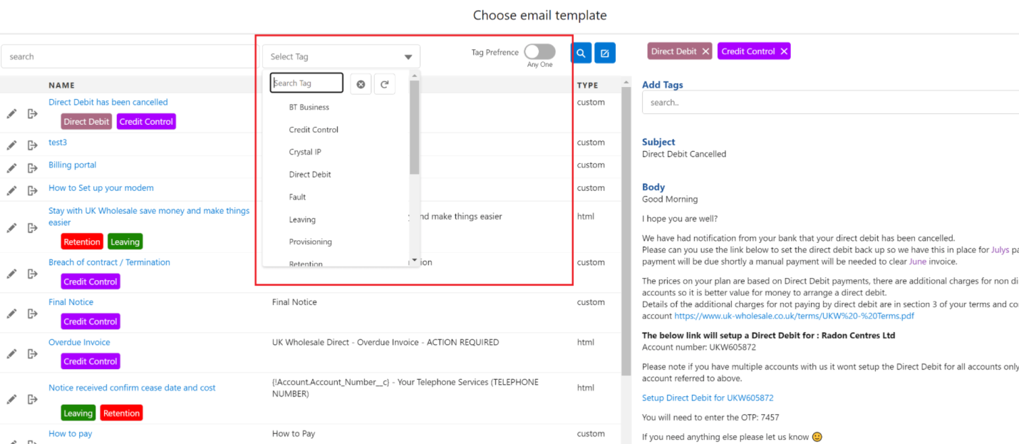

as you start typing in the tag box it filters the tags for you to choose

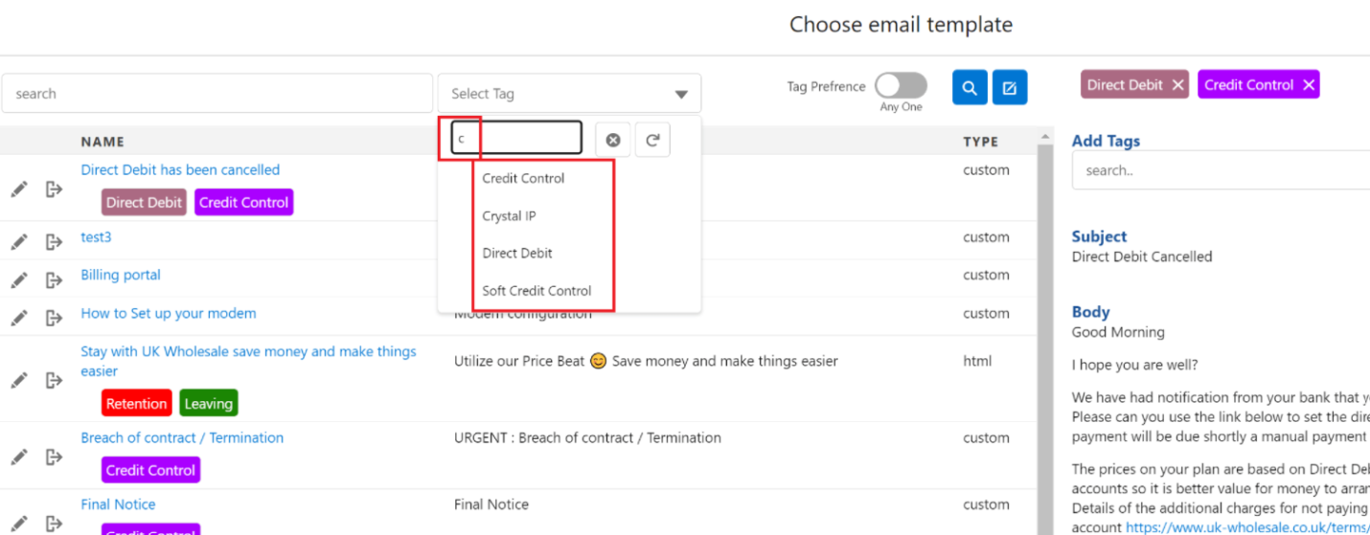

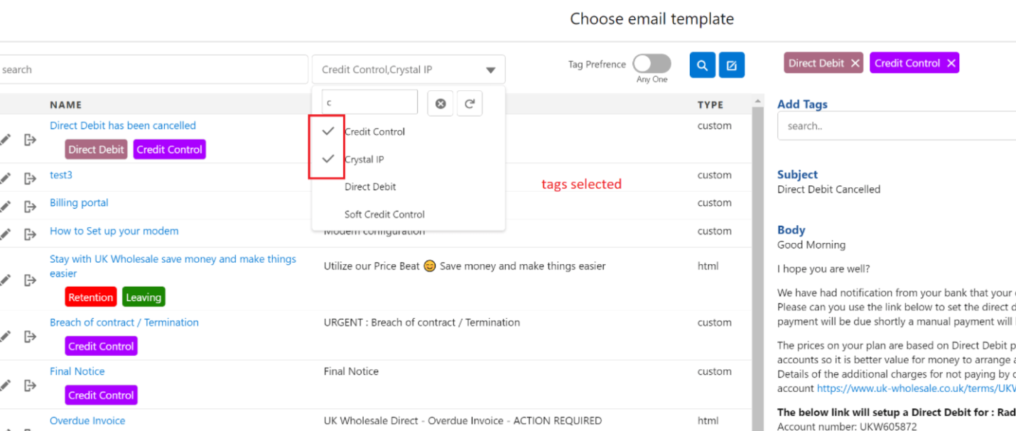

from the same screen I can edit one, or create a new one, delete one

we need user control, 2 levels of role, user and admin

they need to be able to login to view, so that its secure from the outside world

password resets to their email

as I said before, admin need a screen to view edits or new articles, and have a button to approve them, and edit them from the same screen

one thing that works quite well for tags is that to add or remove them you can do it from the "View" screen above so you can quickly move down the list and add/remove tags. This helps

If you have to load it in to edit mode each time to add a tag, its probably a bit too slow so not as many tags get added

in the body of the articles we should easily and quickly be able to put video, pictures, tables, copy and past from word etc. Quick and easy for the user user experience is the key

maybe a way for the user to get a quick link to an article, I guess with this we could use it in an article to say also look at this and this. Maybe we could also put the link in our CRM on a case, although this would be less likely but still possible.

**User:** name, email, drop-down user/admin

**Text search** is to search the article title/subject as well as the article body